UAE Investment Overview
The UAE is a constitutional federation of seven emirates. The Constitution of the UAE provides for five federal authorities. They are:
- The Supreme Council
- The President and the Vice-President
- The Cabinet
- The Federal National Council
- The Federal Judiciary.
Since February 2002, the Arab Emirati Dirham (AED) is pegged to the US dollar (USD).

Linked to the website: 1 USD = AED 3.6725.
• The UAE showed robust growth in 2025, driven by strong non-oil activity (tourism, real estate, logistics, services) and continued energy sector investment. The IMF and World Bank both project growth around ~4.8% in 2025, with the IMF raising its forecast to 5.0% for 2026.
• Inflation in 2025 remained low/moderate (around ~1–2%), easing pressure on domestic prices.
• Monetary policy has been aligned with US Fed moves to preserve the AED-USD peg; the Central Bank of the UAE (CBUAE) cut its base rate in 2025 following US easing.
• Sovereign creditworthiness stays high (ratings affirmed in 2025 by top agencies — S&P, Moody’s, Fitch). Public debt remains moderate by international standards.
• Key near-term upside: continued tourism demand and ADNOC capacity expansions. Key downside: oil price shocks, regional geopolitical risks, and a global slowdown.
Drivers: Non-oil sectors (tourism, real estate, logistics, financial services, construction) and public/private investment in energy and infrastructure. The push to expand oil & gas capacity also supports growth via investment and jobs.

Summary
- Real GDP growth (2025): 4.8% (IMF WEO / World Bank).
- IMF 2026 growth forecast: 5.0% (2026).
- CPI inflation (2025): ~1.6% (IMF WEO average).
- CBUAE policy action (Oct 29, 2025): base rate cut 25 bps (4.15% → 3.90%).
- ADNOC capacity target: ~5.0 million b/d capacity by 2027 (with reporting that 2025–2026 could see earlier increases).
- Dubai tourism: 9.88m visitors H1 2025; 15.7m in 10 months (multiple DET reports / media).
- Sovereign ratings (2025): S&P/Fitch/Moody’s affirmed high ratings (AA- / Aa2 / etc.).

1) International Holding Company (IHC)
Ticker: ADX-IHC
Market cap: ~AED 238 billion (~$65 bn) Market Cap Watch
Share price: ~AED 108.9 Market Cap Watch
Summary (gpt):
IHC is the largest publicly traded conglomerate in the UAE by market value. It holds diversified businesses across sectors — healthcare, food & beverage, energy, financial services, and real estate. The company has been on an aggressive expansion path, with a major capex and acquisition plan (e.g., plans to invest ~$36 bn every ~18 months). Its growth comes from both acquisition and internal scaling, but financials can be complex because of scale and diversification
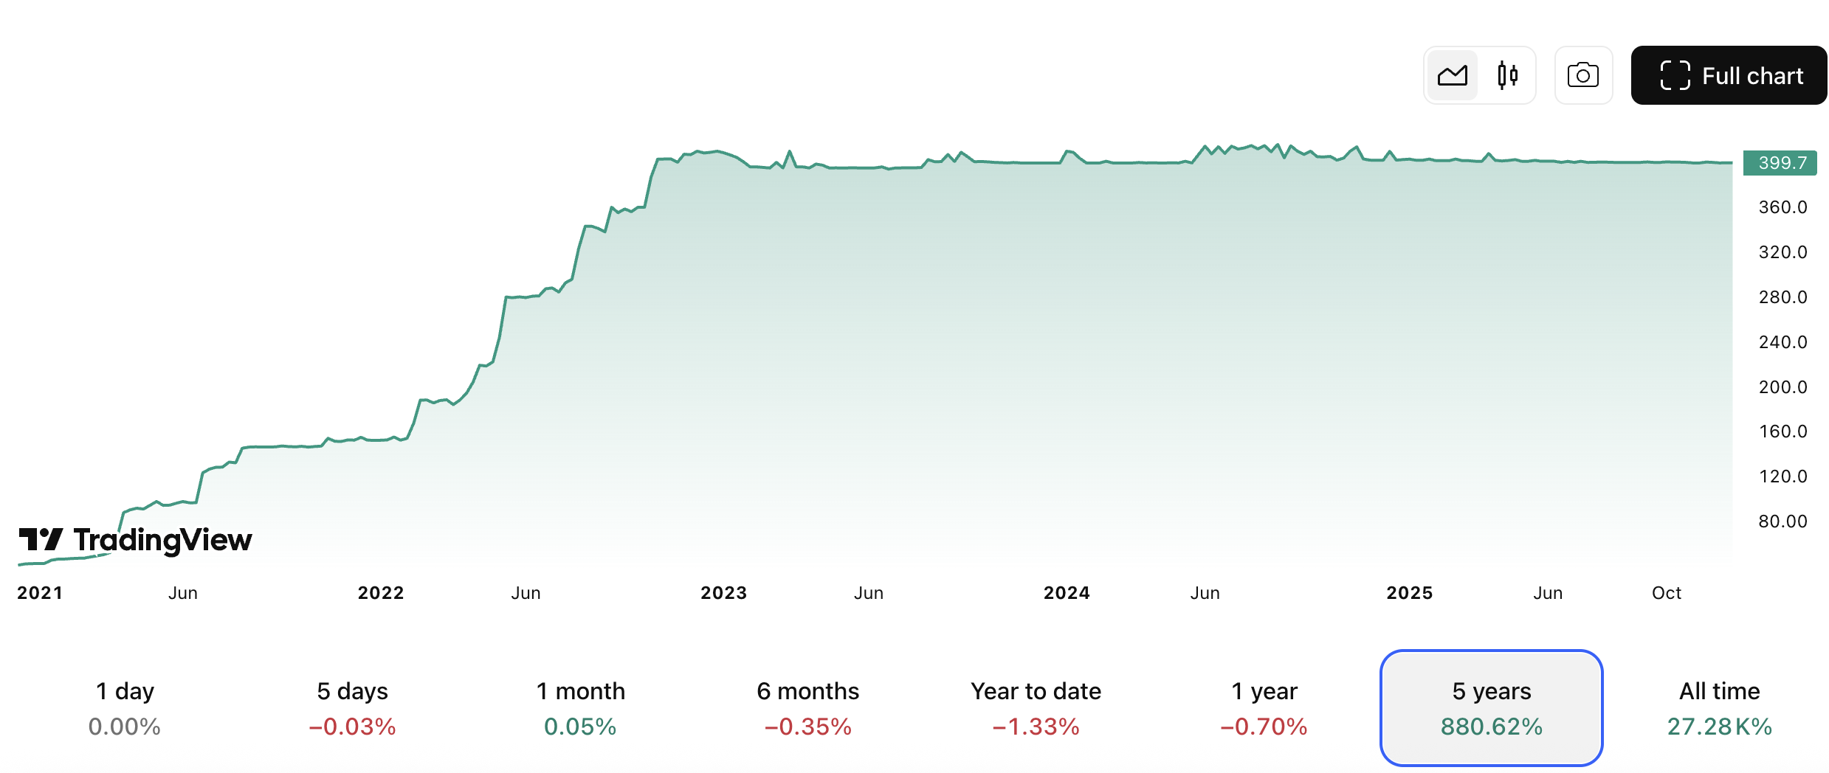

2) First Abu Dhabi Bank (FAB)
https://www.tradingview.com/symbols/ADX-FAB/?timeframe=60M
Ticker: ADX-FAB
Market cap: ~AED 47.6 billion (~$13 bn) Market Cap Watch
Share price: ~AED 4.31 Market Cap Watch
Summary (gpt):
FAB is the UAE’s largest bank by assets, with a broad institutional and retail footprint across the UAE, Middle East, and international markets. Strong capital ratios and diversified revenue make it a core financial play. Earnings typically trend with loan growth and interest margins.
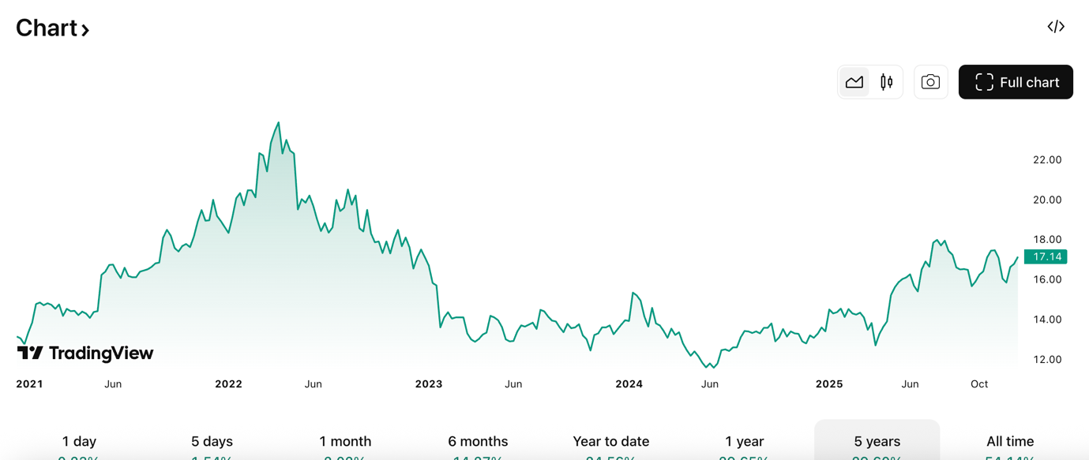

3) Emaar Properties P.J.S.C.
Ticker: EMAAR (Dubai Financial Market)
Sector: Real estate development, commercial leasing, retail, hospitality & entertainment
Headquarters: Dubai, UAE
Business model: Property developer + asset operator (malls, hotels, entertainment) Emaar Properties
Emaar is the developer behind Burj Khalifa, Dubai Mall, and other landmark projects. It operates across property development, recurring revenue assets (malls, hotels), and international projects. Emaar Properties

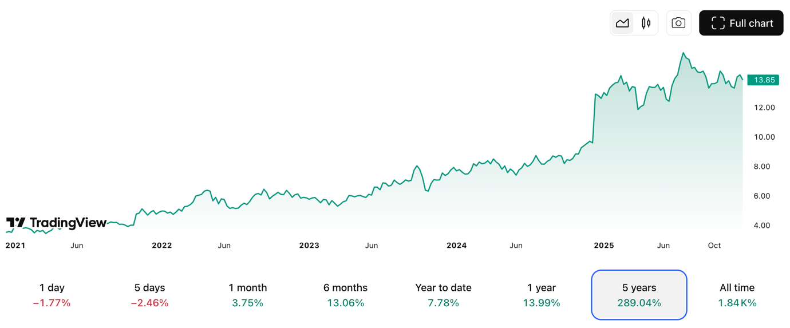

2024 – Record Year
- Property sales: ~AED 70 billion (~US$19 billion), up 72% vs 2023.
- Revenue: AED 35.5 billion (~US$9.6 bn), up 33%.
- Net profit before tax: ~AED 18.9 billion (~US$5.1 bn), up 25%.
- Backlog: >AED 110 billion (~US$30 bn) of future revenue already sold.
- Dividend: Record payout ~AED 8.8 bn (~100% of share capital)
This was Emaar’s strongest performance ever
Credit ratings upgraded in 2025 by both major agencies:
- S&P: upgraded to BBB+ (Stable).
- Moody’s: upgraded to Baa1 (Stable).

Chimera S&P UAE Shariah ETF (CHAESHIN.AE)
Index tracked: S&P UAE Domestic Shariah Liquid 35/20 Capped Index: an index of Shariah-compliant UAE stocks that meet S&P’s eligibility rules (no interest business, low debt, etc.)
“UAE Shariah-compliant stocks” =
UAE companies whose activities and finances avoid interest, excessive debt, and prohibited sectors.
- Assets under management (AUM): ~AED 148 million (~US$40 m). Chimera Investment
- NAV (latest): ~AED 9.26 per share (mid-Dec 2025). Chimera Investment
- Inception date: 20 July 2020. StockAnalysis
- Number of holdings: ~30 UAE companies that satisfy Shariah screens. Chimera Investment
- Expense ratio: ~1.0% per year (estimated broadly; exact may vary by share class). StockAnalysis

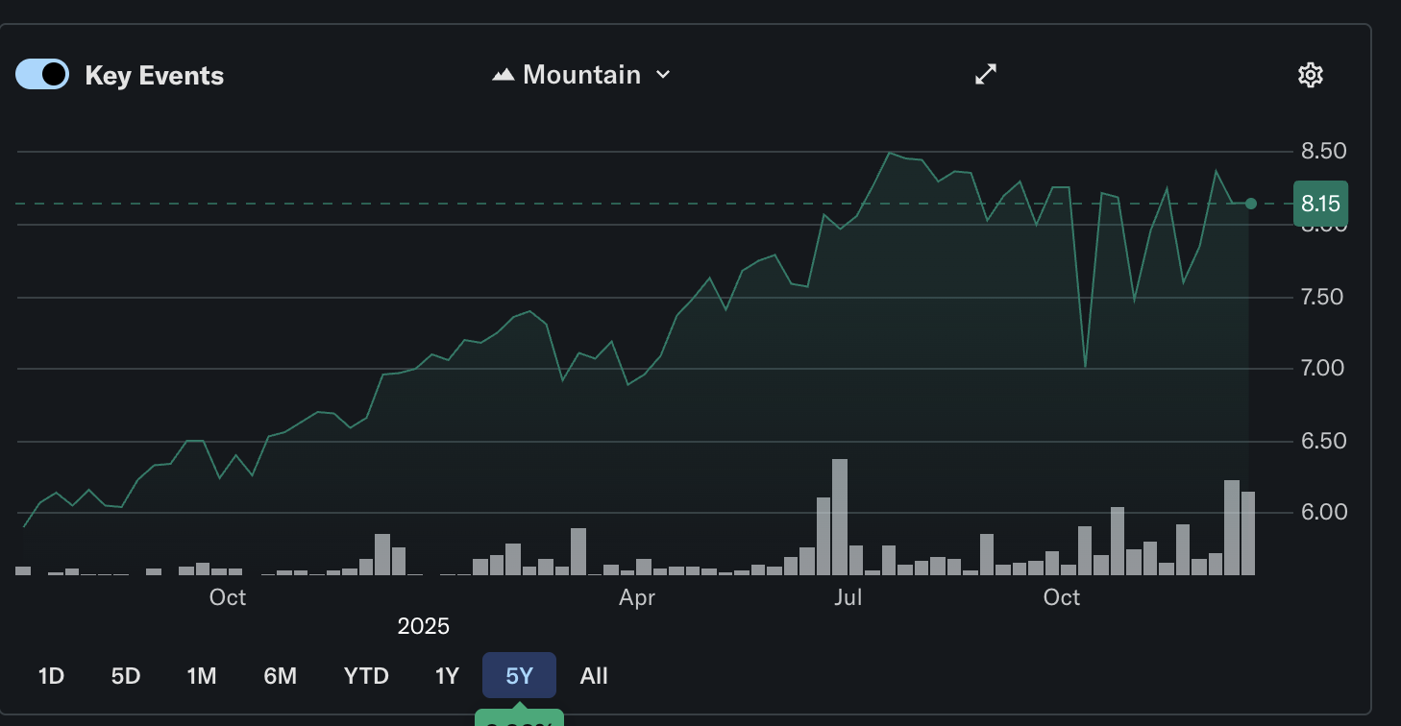

ADNOC Gas plc
Name: ADNOC Gas plc
Ticker: ADX: ADNOCGAS
Exchange: Abu Dhabi Securities Exchange (ADX)
Sector: Energy – Natural Gas Processing & Sales
Parent: Majority owned (~86%) by Abu Dhabi National Oil Company (ADNOC), the UAE’s state energy powerhouse ADNOC
Supplies about 60% of the UAE’s domestic gas needs and exporting to 20+ international markets.

Market Cap & Share Price Context (2025)
- Market Cap: ~AED 265–267 billion (~US$72–73 billion), reflecting solid valuation growth since IPO.
- Share price range: Recent trading has been around AED ~3.46–3.52 per share with a 52-week range of ~AED 2.71–3.71.
- Float: Free float remains relatively low (~9%), though marketed offerings have increased it from IPO levels, modestly boosting liquidity.
- P/E: ~13-14x based on recent reported earnings

Real Estate & Tourism
Real Estate Momentum: Residential real estate sales transactions increased by 13.7% year-on-year in the first 5 months of 2025, with off-plan sales seeing 14.3% growth.
Tourism Strength: Dubai welcomed 9.9 million international overnight visitors in H1 2025, a 6.1% increase compared to H1 2024. Abu Dhabi and Dubai airports handled record passenger numbers, underscoring aviation's role in growth.

